**CSE / EEE / ETE 499A (Section 02)**

**Project Proposal (CO1)**

**Project Title: Ecommerce based Product Recommended System**

**Submitted To**

**Dr. Shazzad Hosain (SZZ)**

**Date: 28/06/2021**



**Group No: 07**

**Group Members**

|  |  |
| --- | --- |
| **ID** | **Name** |
| 1722351642 | Md. Hasibul Hasan |
| 1731699642 | Zeeshan Jamal |
| 1721444042 | Md. Ashiqur Rahman Ovi |
| 1711376042 | Md. Mukith Al Alim |

1. **Introduction**

In this paper, we are going to study about recommendation systems. Recommendation systems are typically used by companies, especially e-commerce companies like Amazon.com, to help users discover items they might not have found by themselves and promote sales to potential customers. A good recommendation system can provide customers with the most relevant products. This is a highly-targeted approach which can generate high conversion rate and make it very effective and smooth to do advertisements. So, the problem we are trying to study here is that, how to build effective recommendation systems that can predict products that customers like the most and have the most potential to buy. Based on the research on some existing models and algorithms, we make application-specific improvements on them and then design three new recommendation systems, Item Similarity, Bipartite Projection and Spanning Tree. They can be used to predict the rating for a product that a customer has never reviewed, based on the data of all other users and their ratings in the system. We implement these three algorithms, and then test them on some existing datasets to do comparisons and generate results.

**Discussion:**

 A product recommendation system is a software tool designed to generate and provide suggestions for items or content a specific user would like to purchase or engage with. Various data about both individual products and individual users, the system creates an advanced net of complex connections between those products and those people.

There are three basic types of connection a product recommendation system creates:

* User-product relationships: based on users’ individual product preferences.
* User-user relationships: based on similar people (i.e., people of a similar age, background, etc.) likely having similar product preferences.
* Product-product relationships: based on similar or complementary products (e.g., printers and ink cartridges) that can be categorised into relevant groups.

Product recommendation systems compare and rank these connections, and recommend products or content accordingly.

1. **Literature Review / Existing Projects**

Research the literature and provide formal citations from publications in the Reference Section. Similar other projects that have already be done for local and / or international market.

Piletskiy et al. has developed and analysed an intelligent product recommendation system using machine learning [1]. Recommendation systems generate recommendations independently for each specific user based on their previous purchases and searches as well as on the basis of the behaviour of other users [1]. In their research they have applied SVD algorithm for developing recommendation system [1]. MVC Architectural pattern is used for web development [1]. The implementation represents a three-tier architecture (DAL, BLL, WEB) [1]. Program realization of recommendation system was made using .Net framework [1].

A group of researchers from Jeju National University, Korea did research on improving the Prediction Accuracy of Product Recommendation System Using Extreme Gradient Boosting and Encoding Approaches [2].  Shahbazi et al. embraced plethora of approaches including collaborative filtering algorithm to tackle big data of user with symmetric purchasing order and repetitive purchased products [2]. They have also implemented Mean Absolute Error, Mean Square Error, and Root Mean Square Error for their proposed methodology and also other machine learning algorithms- *XGBoost,* *Random Forest, Support Vector Regressor* and *Linear Regressor* [2]*.*

A group of researchers have done work on hybrid online-product recommendation system [3]. They have combined implicit rating-based collaborative filtering and sequential pattern analysis [3].

Based on several experiment results comparing between their and others’ performance they have concluded that the implicit rating can replace explicit rating successfully in collaborative filtering and the hybrid approach of collaborative filtering and sequential pattern analysis are better than the individual ones [3].

Research team led by Adenyi did research on automated web usage data mining and recommendation system using K-nearest Neighbour (KNN) classification method [4]. They have applied K-Nearest [Neighbour classification](https://www.sciencedirect.com/topics/computer-science/neighbor-classification) method in online and  Real-Time to exploit web usage data mining technique to identify clients/visitors click stream data matching it to a particular user group and recommend a tailored [browsing option](https://www.sciencedirect.com/topics/computer-science/browsing-option) that meet the need of the specific user at a given time[4]. The MATLAB software was used for interpretation and graphical presentation of the result obtained [5].  The process of the development of the automatic Real-Time web usage mining and recommendation application was done by adopting the [Java programming language](https://www.sciencedirect.com/topics/computer-science/java-programming-language) with NetBeans as the editor and compiler [6].

1. **Business viability of the project**
2. Novelty of the proposed project: The idea of our project is quite popular now-a-days. Most of the international e-commerce-based websites have recommendation system implemented in their system. But very few websites of our country provide a good recommendation system. Internationally popular websites like – YouTube, Netflix, Facebook, Amazon all are using recommendation system in their respective platforms.
3. Market segments: In our country there are many websites which doesn’t have any recommendation system implemented in it. Recommendations helps to increase the sales as well. So, it has huge benefit both from the website’s owner side and customer side. There is no doubt that recommendation system makes a positive impact on the growth of eCommerce business. Our recommendation engine can be implemented in any e-commerce-based website for engaging the users with more and more products.  Judging by Amazon's success, the recommendation system works. The company reported a 29% sales increase to $12.83 billion during its second fiscal quarter, up from $9.9 billion in one year.
4. Competitor analysis: Most of the Bangladeshi owned e-commerce-based website has no recommendation system. By far “Daraz” and “Othoba” has implemented recommendation system.   One or two more websites also shows some kind of recommendation but those recommendations are not good. Many big websites like “Chaldal”, “Rokomari”, “Pickaboo”, “PriyoShop” don’t have recommendation system at all.

**4. Project Analysis**

**a) Major components of the project:**

The Operating Environment for our project includes:

* Operating System: Windows
* Agile Software Development Model
* Machine Learning Algorithms: K- Nearest Neighbor (KNN)

**Tools included:**

Project Management Tool: Jira Software

Communication Tool: Slack

IDE: VSCODE

The recommendation system is designed in 3 parts based on the business context:

* **Recommendation system part I:** Product popularity-based system targeted at new customers.
* **Recommendation system part II:** Model-based collaborative filtering system based on customer's purchase history and ratings provided by other users who bought items similar items
* **Recommendation system part III:** When a business is setting up its e-commerce website for the first time without any product rating.

Recommendation Approaches we will use:

1. Content Based filtering: CBF tracks a user’s actions, such as products bought or click on, web pages viewed, time spent browsing various product categories. It then uses this information to create a customer profile. This profile is then compared to the catalogue to make recommendations.
2. Collaborative Filtering: CF methods involve collecting and analysing information on user’s preferences and predicting what each user will like based on similarity to other users. Like if a user like Linking Park, Metallica. Another user like Coldplay, Metallica. Then CF filtering Algorithm will determine that two users have similar tastes and will recommend Cold play to first user and Linking Park to second.

**b. Target for 499A and 499B:** Our target is to Reviewing Paper, Collecting Dataset and Applying Different Machine Learning Algorithms in 499A and Rest of the implementation, coding in 499B.

**c. Task Analysis: (499A)**

|  |  |  |  |
| --- | --- | --- | --- |
| Task ID | Task Description | Duration (Days) | Dependencies |
| T1 | Project Proposal | 8 |  |
| T2 | Paper Review | 7 |  |
| T3 | Design Report | 8 | T1 |
| T4 | Project Impact Report | 8 | T1, T3 |
| T5 | Collecting Dataset | 8 |  |
| T6 | Model Exploration & Refinement | 7 | T5 |
| T7 | Applying ML Algorithms | 14 | T5, T6 |
| T8 | Testing & Evolution | 7 | T7 |
| T9 | Final Report | 14 | T1, T3, T4 |

**Activity Diagram:**

16 days days

8 days days

T3rt

24 days days

T4rt

T1rt

34 days

16 days

T9rt

0 days

8 days

8 days

0 days

Start

T2rt

END

15 days days

37 days

8 days days

T8rt

T6rt

0 days

29 days

T7rt

15 days

T5rt

d. Timeline

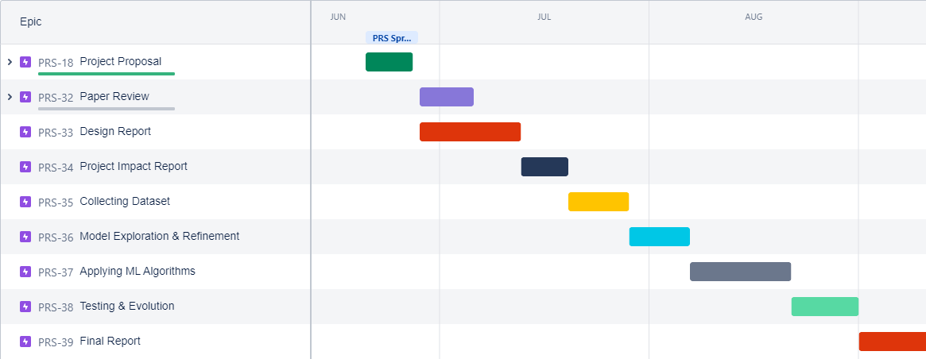

e. Cost Analysis

|  |  |  |  |
| --- | --- | --- | --- |
| SL | Description | Expense | Comment |
| 1 | Analysing & Raw Estimate | 0$ |  |
| 2. | Paper Review | 10$ | Paid Site |
| 2. | Hosting | 20$ | AWS or Free |
| 3. | Dataset | 0$ | Kaggle |
| 4. | Others | 20$ |  |
|  | Total | 50$ |  |

**References:**

1. Piletskiy P., Chumachenko D., Meniailov I. (2020) Development and Analysis of Intelligent Recommendation System Using Machine Learning Approach. In: Nechyporuk M., Pavlikov V., Kritskiy D. (eds) Integrated Computer Technologies in Mechanical Engineering. Advances in Intelligent Systems and Computing, vol 1113. Springer, Cham. <https://doi.org/10.1007/978-3-030-37618-5_17>
2. Shahbazi, Z.; Hazra, D.; Park, S.; Byun, Y.C. Toward Improving the Prediction Accuracy of Product Recommendation System Using Extreme Gradient Boosting and Encoding Approaches. *Symmetry* **2020**, *12*, 1566. <https://doi.org/10.3390/sym12091566>
3. Keunho Choi, Donghee Yoo, Gunwoo Kim, Yongmoo Suh, A hybrid online-product recommendation system: Combining implicit rating-based collaborative filtering and sequential pattern analysis, Electronic Commerce Research and Applications, Volume 11, Issue 4,

2012,

Pages 309-317,

ISSN 1567-4223,

<https://doi.org/10.1016/j.elerap.2012.02.004>.

1. D.A. Adeniyi, Z. Wei, Y. Yongquan,

Automated web usage data mining and recommendation system using K-Nearest Neighbor (KNN) classification method,

Applied Computing and Informatics,

Volume 12, Issue 1,

2016,

Pages 90-108,

ISSN 2210-8327,

<https://doi.org/10.1016/j.aci.2014.10.001>.

(<https://www.sciencedirect.com/science/article/pii/S221083271400026X>)

1. Mathworks Incorporation., MATLAB R2011b (7.13.0.564), Licence Number: 161052, USA, Mathworks Incorporation, 1984–2011.
2. NetBeans IDE 7.3, NetBeans java compiler. USA, Java/Oracle corporation, 2008.